Parent Portal Guide for Parents
2015-2016

Creating Your Parent Account
Before using the parent portal, you must pick up your access id and password from the school. This information must be picked up in person in order to keep your child’s personal information secure and private.

- Open up a web browser and navigate to https://ps.greenville.k12.sc.us/public/
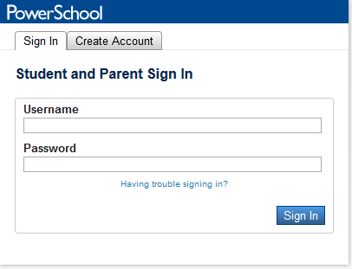
- The first time you logon to the parent portal, click the Create Account tab at the top of the screen. This will allow you to set up your username/password and tie students to your account.
- Fill out the required information on the screen:
  - First Name
  - Last Name
  - Email
  - Username (must be unique and not have any special characters such as !& or @ symbols)
  - Password (must be a least 6 characters long)
  - Re-enter Password

- Under the Link Students to Account section, enter your student’s name and the Access ID and Access Password you received from the school. Choose the relationship to the child.
- Add additional children (up to 7 - Access ID and Password required) to link all children to your account so that you only have to sign in one time to view all your children’s information.

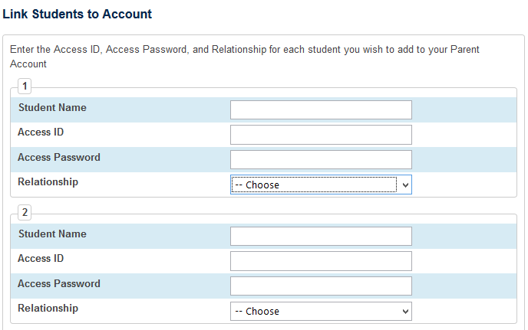

- Click the Enter button at the bottom of the page
- Login to your account to view your children’s information
Parent Portal Overview
When you first login to Parent Portal, you will see several icons along the side of the page. These icons represent the various information you have access to as a parent.

Here you will see your child’s or children’s name(s) across the top left hand of the screen. You can click on the each child’s name to switch between them. By default, the screen opens to the Grades and Attendance screen. Click on different icon to see that information related to the child.

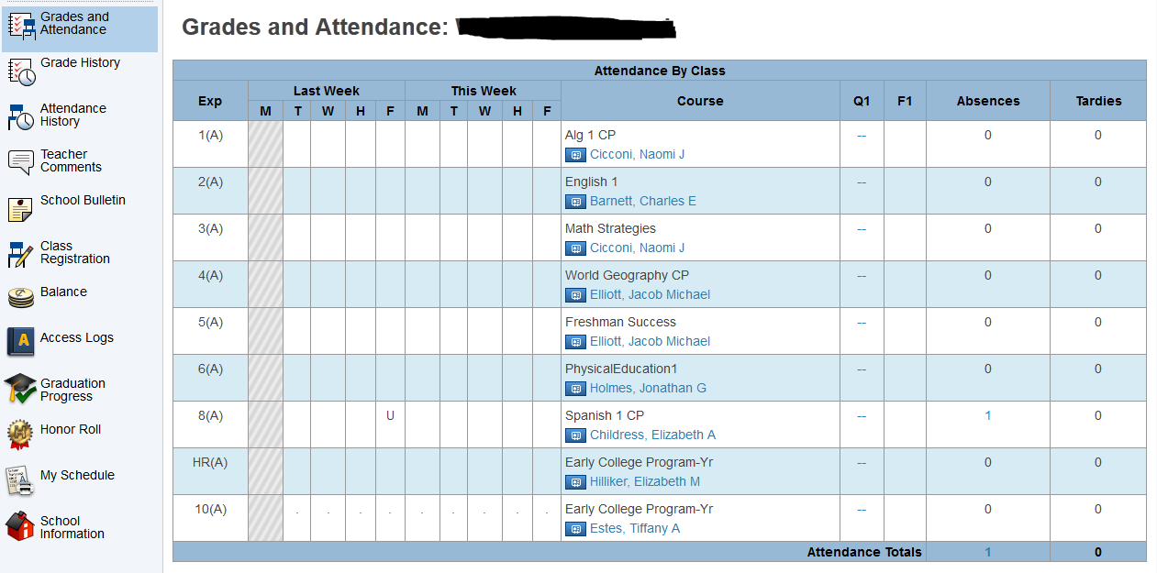

Editing your Account and Adding Additional Children
Parent portal allows you to combine all your children into one account. The benefit of this is that you only have to login one time to see all your children’s information. You can set up all your children when you first sign up for an account, or just set up one of your children and add the others later. The directions below will walk you through how to add additional children to your existing account.
- Login to Parent Portal with your Username and Password
- Click on the Account Preferences Icon
- By default, the Profile tab opens up. This allows you to change your account information (name, email, username and password).
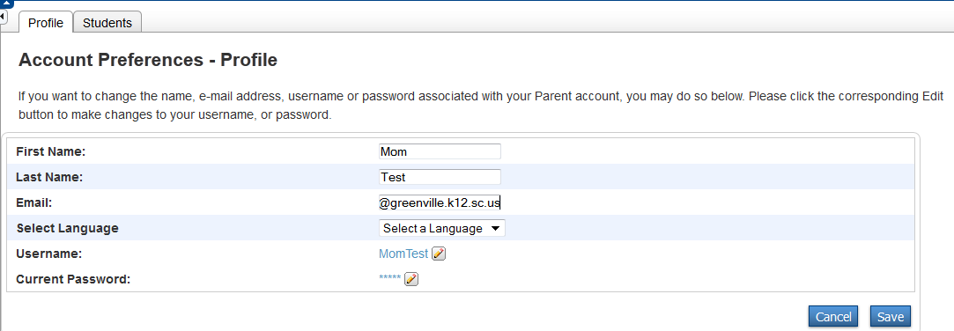

- Click the Students tab, next to the profile tab at the top of the window.

- You will see Your Students listed in the box. To add another child, click the Add button in the top right box
- Fill out the required information (Student Name, Access ID and Access Password for that child and the relationship).
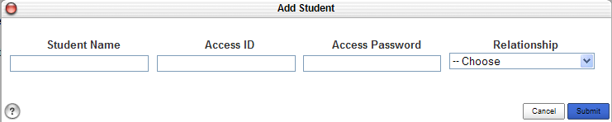

REMEMBER: EVERY CHILD HAS A DIFFERENT ACCESSS ID AND PASSWORD. YOU WILL NEED TO GET THAT FROM EACH CHILD’S SCHOOL BEFORE SETTING UP ACCOUNTS.

- Click the Submit button when you are finished
- Once you set up additional student accounts, you will see them appear as tabs across the top of the page, under the PowerSchool icon. You can switch from child to child by clicking on their tab.

Changing Email Notification
Parents can change the rate of email notifications that they receive.
- Login to the Parent Portal with your username and account
- Select Email Notification icon on the Left Menu bar.
- Check what type of information you would like to receive here.

Please be aware we suggest that you deselect the ‘Detail report of attendance’ since it may cause problems if it is checked.

Student Demographic Change Requests
Parents can make changes to their child’s demographic data. These changes will not be official until they have been approved by the school personnel.
- Login to the Parent Portal with your username and account.
- Select the Demographic Change icon on the left of the page.
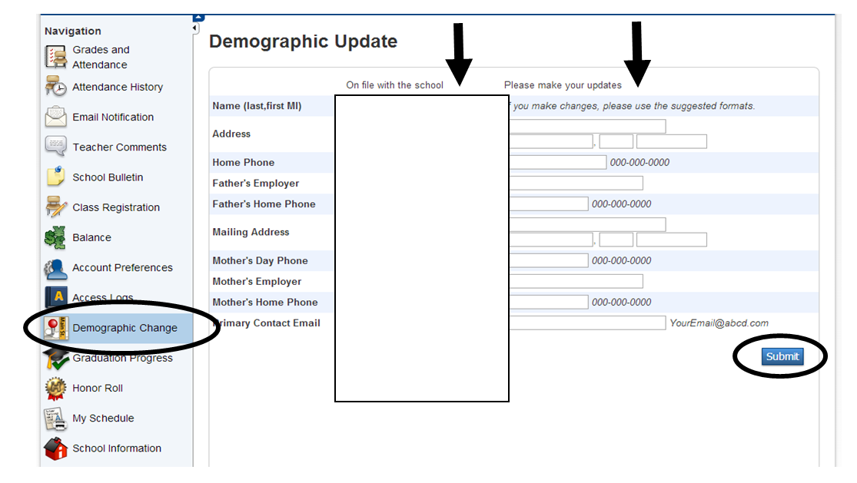

- You can see your current information on file with the school in the Demographic Update section.
- You can type in updates to any field in the Demographic Update section.
- Click the Submit button at the bottom of the page.

Logging Out
If you are using the Parent Portal on a work computer or public place, you will want to logout to make sure no one else can access your account. To logout, click the sign out hyperlink located at the top right corner of the page.

